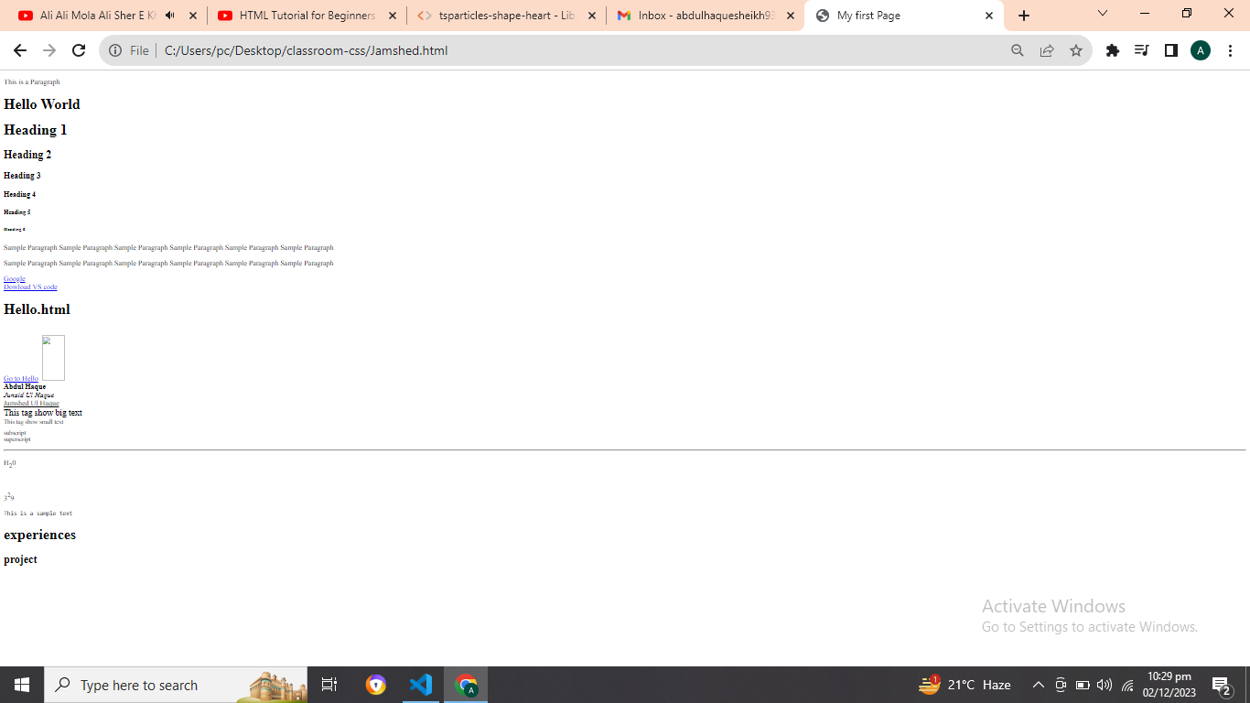





***A******s***

***A.Haque1304$$$$$$***

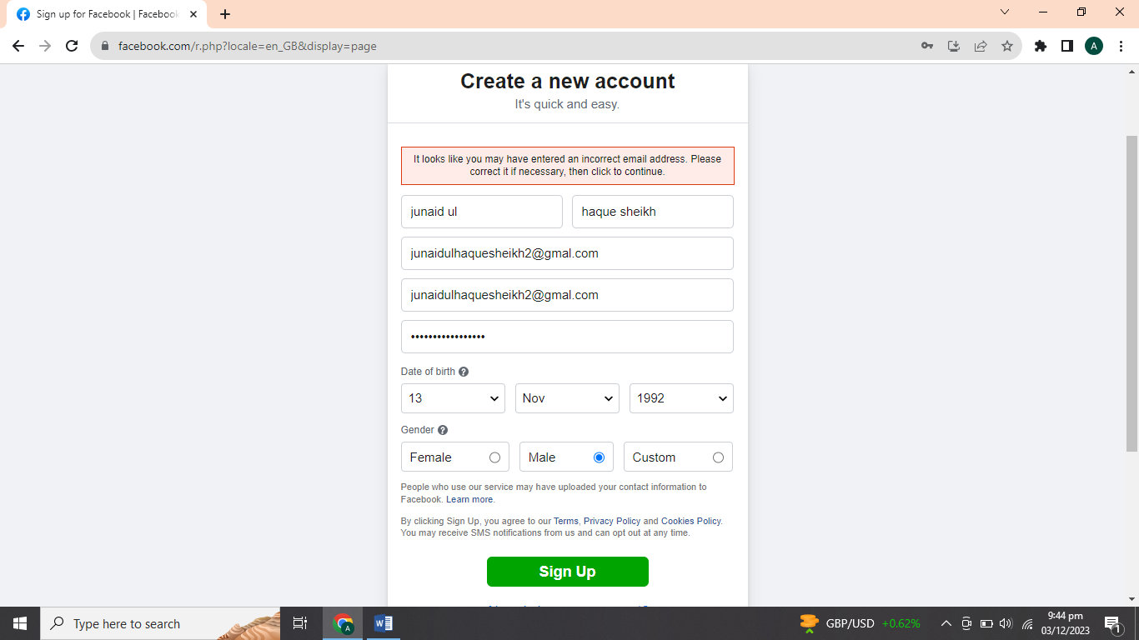    

***A.Haque1304$$$$$$***

***A.Haque1304$$$$$$***

***A.Haque1304$$$$$$***

***junaidulhaquesheikh2@gmal.com***

***junaidulhaquesheikh2@gmal.com***

***Nextjs-lectures:-***

***send me all codings only one spaces only or remove all syntax errors or convert me into import export to all codings with the help of html css scss js or guide me that i am beginners of the class***

***npm list --depth=0 –g***

[***https://github.com/=Hamzah-syed/Nextjs-lectures/commit/bb2390d6b1fdb63a2c99af5739cf9aa38f922b59#diff-303db257d449d968aa1320b423a5b861a366ad47ce3641ff28c77ace7ba2e80c***](https://github.com/=Hamzah-syed/Nextjs-lectures/commit/bb2390d6b1fdb63a2c99af5739cf9aa38f922b59#diff-303db257d449d968aa1320b423a5b861a366ad47ce3641ff28c77ace7ba2e80c)

<https://github.com/Hamzah-syed/Nextjs-lectures/commit/bb2390d6b1fdb63a2c99af5739cf9aa38f922b59#diff-303db257d449d968aa1320b423a5b861a366ad47ce3641ff28c77ace7ba2e80c>

<https://github.com/Hamzah-syed/Nextjs-lectures/commit/bb2390d6b1fdb63a2c99af5739cf9aa38f922b59#diff-303db257d449d968aa1320b423a5b861a366ad47ce3641ff28c77ace7ba2e80c>

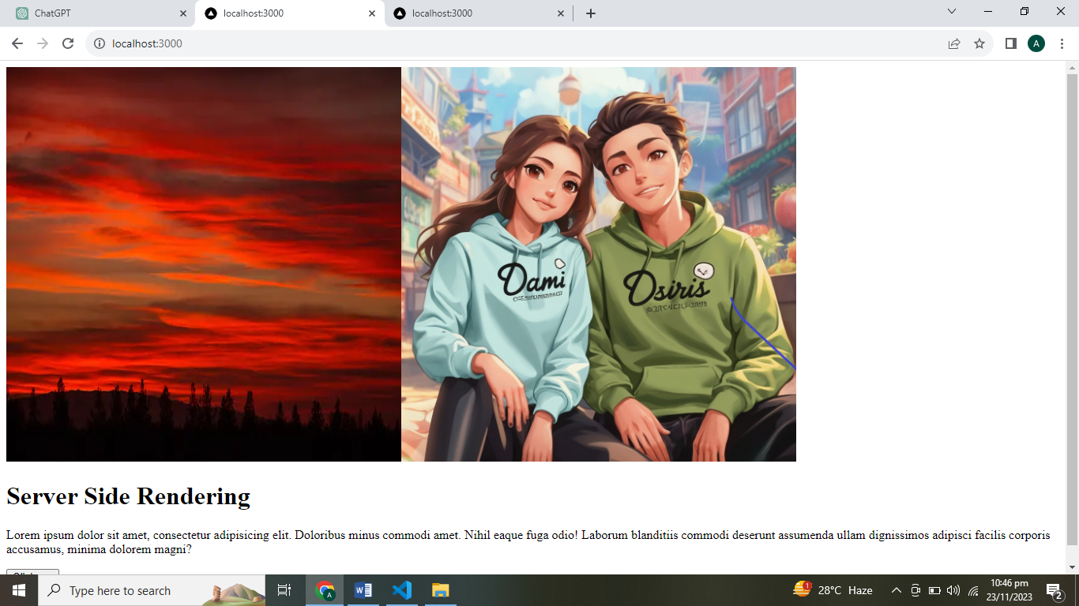

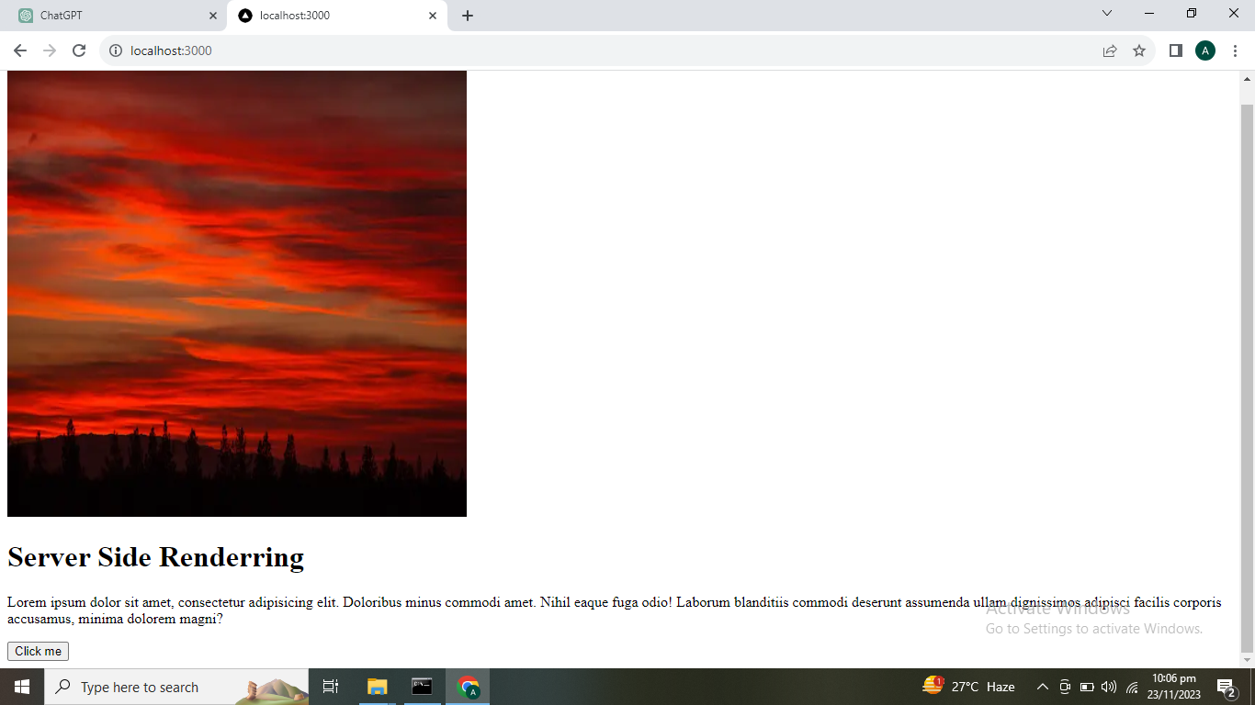

C:\Users\pc\Desktop\class3nextjsbysirhamzasyed\sheikh-classes-0001>npm list --depth=0 -g

C:\Users\pc\AppData\Roaming\npm

+-- create-react-app@5.0.1

+-- live-server@1.2.2

+-- next@14.0.3

+-- npm@10.2.4

+-- ts-node@10.9.1

`-- typescript@5.2.2

C:\Users\pc\Desktop\class3nextjsbysirhamzasyed\sheikh-classes-0001>

npm list –depth=0 –g

P

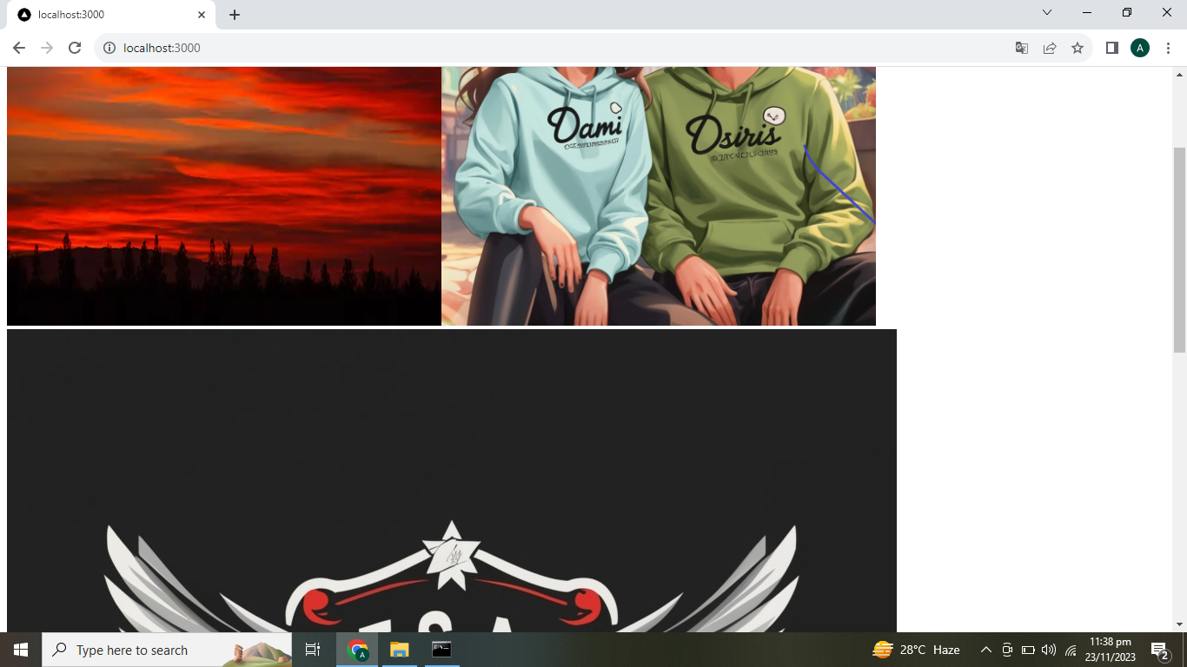

<https://itmatepk.blogspot.com/2023/05/my-first-portfolio-using-next-js-13.html>

***npm list --depth=0 –g***

<https://itmatepk.blogspot.com/2023/05/my-first-portfolio-using-next-js-13.html>

<https://itmatepk.blogspot.com/2023/05/my-first-portfolio-using-next-js-13.html>

<https://itmatepk.blogspot.com/2023/05/my-first-portfolio-using-next-js-13.html>

ackage.lock.json//package.json

Both not working as very as well

<https://chat.openai.com/c/e15e6b0b-898c-4675-9241-8e5c0cb1d0c1>

<https://chat.openai.com/c/e15e6b0b-898c-4675-9241-8e5c0cb1d0c1>

<https://chat.openai.com/c/e15e6b0b-898c-4675-9241-8e5c0cb1d0c1>

* + Ensure that the port on which your web serverhttps://chat.openai.com/c/e15e6b0b-898c-4675-9241-8e5c0cb1d0c1https://chat.openai.com/c/e15e6b0b-898c-4675-9241-8e5c0cb1d0c1https://chat.openai.com/c/e15e6b0b-898c-4675-9241-8e5c0cb1d0c1https://chat.openai.com/c/e15e6b0b-898c-4675-9241-8e5c0cb1d0c1https:

<file:///C:/Users/pc/Desktop/My%20portfolio/My%20Portfolio%20Project%200001/sh>

eikh-portfolio/src/app/component/navbar.tsx

file:///C:/Users/pc/Desktop/My%20portfolio/My%20Portfolio%20Project%200001/

-portfolio/src/app/component/navbar.tsx

<file:///C:/Users/pc/Desktop/My%20portfolio/My%20Portfolio%20Project%200001/sheikh-portfolio/src/app/component/navbar.tsx>

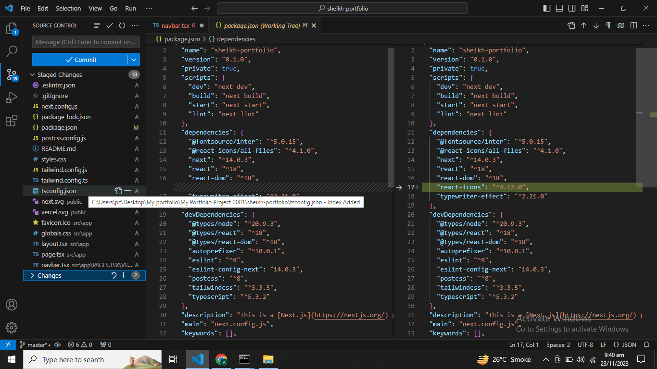

Still error showing continously //

Whatsapp k group main send kardo //

npm init –y

npm install typescript --save-dev

npx tsc –init

npx tsc

npm install -g live-server

npm install --save-dev @types/node

npm install some-package –save

git init

git add .

git commit -m "Initial commit"

npx create-next-app my-nextjs-app

npm run dev

npm run build

npm start

npm install

npm –v

node –v

next –v

npm run export

npm run lint

npm testnpm install some-package –save

git init

git add .

git commit -m "Initial commit"

npm install -g vercel

vercel

npm install react-icons –save

npm i typewriter-effect

yarn add typewriter-effect

**install for rafce**

ES7+ React/Redux/React-Native/JS snippets

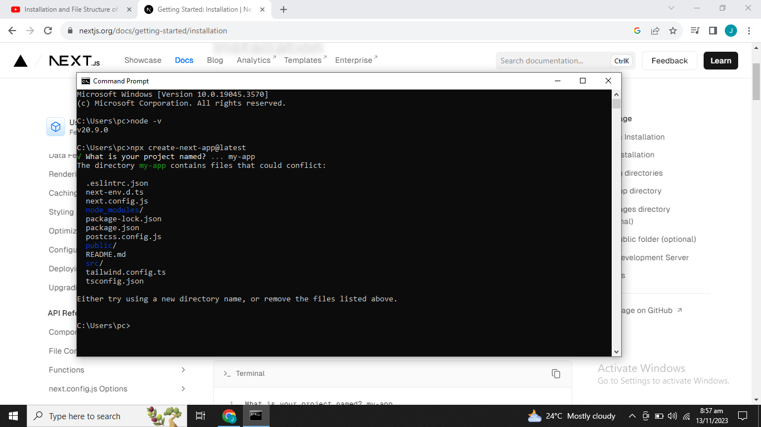

npx create-next-app@latest watches-app-0001

